Report of | Meeting | Date
Director of Finance | Governance Committee | Tuesday 23 May 2023

CIPFA Resilience Index

Is this report confidential? | No

Is this decision key? | No

Savings or expenditure amounting to greater than £100,000 | No

Purpose of the Report

- To present to the Governance Committee the latest CIPFA Resilience Index (2021/22) compared to the previous published indices.

Recommendations
- The Governance Committee are asked to note the index and the continued strong position of the Council.

Reasons for recommendations
- The index compares key financial indicators with other Local Authorities and the results are intended to provide assurance to the Governance Committee.

Other options considered and rejected
- Not applicable.

Corporate priorities

- The report relates to the following corporate priorities:

An exemplary council | Thriving communities
A fair local economy that works for everyone | Good homes, green spaces, healthy places

Background to the report

- An online index was released by CIPFA (Chartered Institute of Public Finance and Accountancy) in December 2019 to show the levels of financial resilience of each Local Authority across England.

- The index is intended to help to ensure the sector is held to collective and robust standards of governance and financial management.

- Indicators used in the index include levels of reserves, external debt and ratios of income and expenditure.

- These measures are intended to provide a rounded picture of an authority’s resilience to financial shocks.

- Whilst the index is intended to support Local Authorities in conducting their long term resilience assessments it is important to remember that it forms only one part of that judgement. Local context must also be taken into account when forming an overall picture of resilience.

- The index is based upon statistical returns submitted by Local Authorities and it should be recognised that data quality / consistency will be an issue as different organisations will undoubtedly have different approaches to completing these.

- The index is valid however in making overall comparisons and comparing trends between years.

- CIPFA have now released the 2021/22 index; this is analysed in the report and compared against data from previous years.

THE INDICATORS
14. The 8 indicators applicable to District Councils are as follows;
INDICATOR | DEFINITION
Reserves Sustainability Measure | Ratio between the current level of reserves and the average change in reserves in each of the past 3 years.  A negative value (which implies reserves have increased) or one greater than 100, have been recoded to 100).  (A higher figure indicates stronger resilience)
Level of Reserves | Ratio of current level of reserves to the council’s net revenue expenditure.  (A higher figure indicates stronger resilience)
Change in Reserves | Average % change in Reserves over the past 3 years  (A higher, positive figure indicates stronger resilience)
Interest Payable / Net Revenue Expenditure | Ratio of Interest Payable to Net Revenue Expenditure  (A lower figure indicates stronger resilience)
Gross External Debt | Compares gross external debt held by a council
Fees and Charges to Service Expenditure Ratio | Proportion of fees and charges against the council’s total service expenditure  (Measures dependency on fees and charges and also how effective the council has been in generating income in this way)
Council Tax Requirement/Net Revenue Expenditure | Ratio of council tax as a proportion of net expenditure  (Measures dependency on Council Tax and how effective the council has been in moving away from dependency on grants and funding from central government)
Growth Above Baseline | Difference between the baseline funding level and retained business rates income, over the baseline funding level

SOUTH RIBBLE PERFORMANCE
15. The indicators are available for all authorities in the country and can be selected individually or by reference to;
- Upper Tier or Lower Tier and then by,
- County Councils/ London Boroughs/ Metropolitan Districts/ Non-Metropolitan Districts/ Unitaries OR Nearest Neighbour
16. For the purposes of this comparison, South Ribble have been compared to their “Nearest Neighbours”. The CIPFA Nearest Neighbour Model adopts a scientific approach to measure the similarity between authorities taking into account a range of economic, social and physical characteristics.
17. The Nearest Neighbour Grouping has been revised by CIPFA in the 2021/22 index and is now as follows;
Amber Valley
Braintree
Broxtowe
Charnwood (new for 2021/22)
Chorley
Erewash
Gedling
High Peak
Hinckley & Bosworth
Newark & Sherwood
Rossendale
South Derbyshire
South Kesteven (new for 2021/22)
South Ribble
Stroud
Kettering and Stafford were in the grouping for 2020/21, however have been removed for 2021/22
18. The indicators are outlined in the attached charts; compared with previous years.
19. It should be noted that on some graphs the scale has changed between years.
CONCLUSION
20. There has not been a significant shift in either the scale of the Council’s indicators, or their position in the “rankings” of the comparator Group.
21. The indicators continue to highlight the Council remains in a strong position.
22. The indicators highlight the Council currently has no external borrowing, however potentially this could change with a number of capital schemes planned. This in turn should give the Council greater opportunities for income generation.

Climate change and air quality

- The work noted in this report does not impact the climate change and sustainability targets of the Council’s Green Agenda and all environmental considerations are in place.

Equality and diversity

Not applicable.

Risk

- The analysis provides assurance that the Council is in a strong financial position and resilient to financial risks.

- Members should note however that there are significant financial challenges ahead in terms of pay & price inflation, customer demand and potential changes to the funding / business rates mechanism for Local Authorities.

Comments of the Statutory Finance Officer
- There are no direct financial implications arising from this report.

- The report presents the financial standing of the council based on the figures included in the 2021/22 statutory returns for South Ribble in comparison to a group of councils who CIPFA deem to be the best comparator group based on similarities across a range of economic, social and physical characteristics.

Comments of the Monitoring Officer
- There are no legal concerns with the report. No further comments in addition to above.

Background documents

There are no background papers to this report.

Appendices

Appendix A – Comparison of Resilience Indices
Report Author: | Email: | Telephone: | Date:
Steve Kenyon (Interim Deputy Director of Finance) | steve.kenyon@southribble.gov.uk | 01257 515151 | 26th April 2023

APPENDIX A
- Reserves Sustainability Measure

2021/22 | 2020/21 | 2019/20
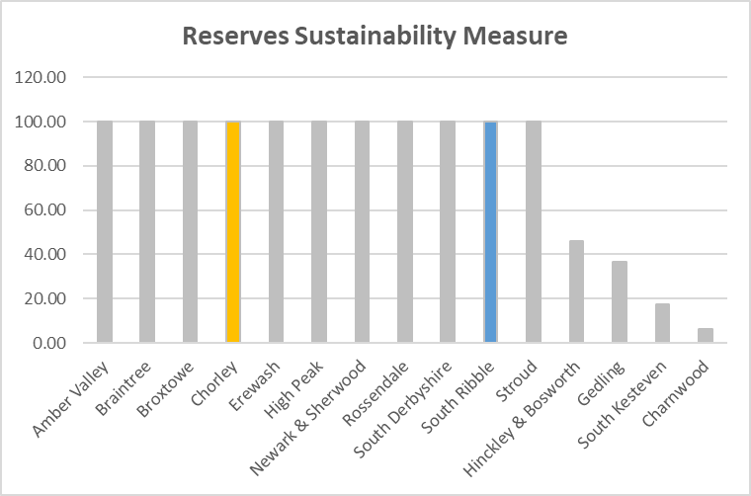 | 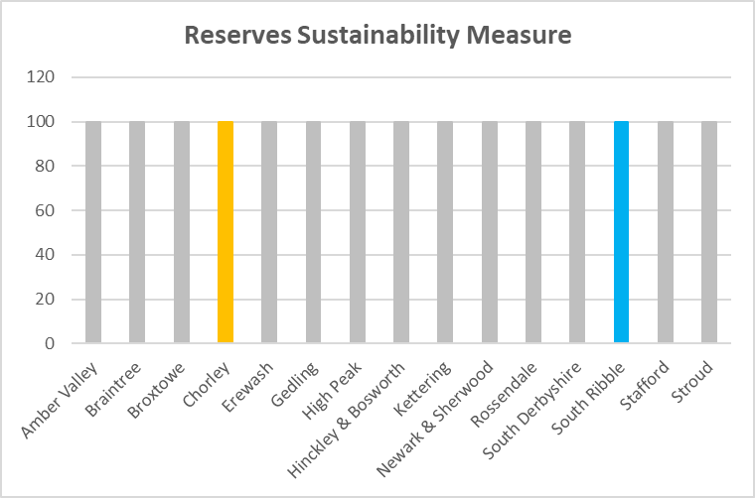 | 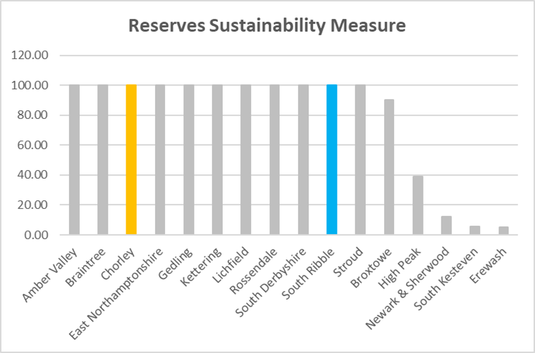

The charts highlight a continuing strong level of reserves (maximum level on chart), with growth over the last 3 years for the Council.

- Level of Reserves

2021/22 | 2020/21 | 2019/20
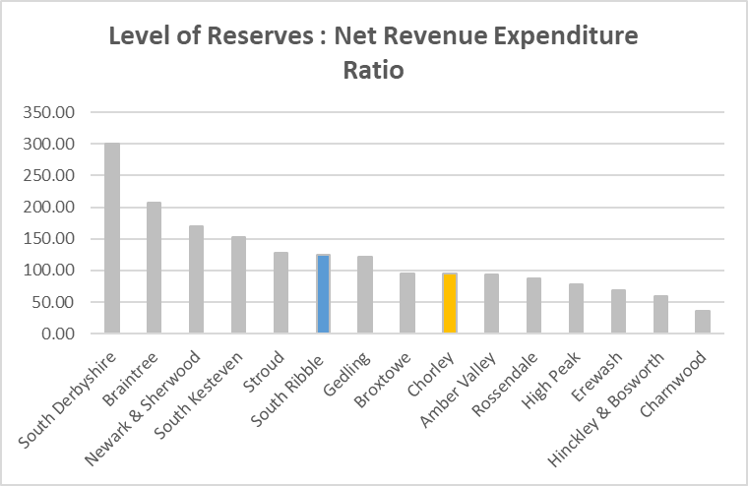 | 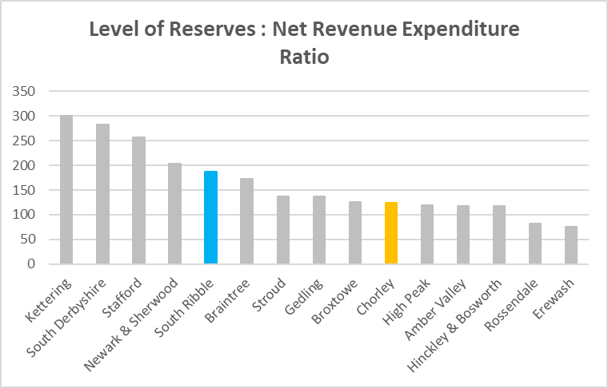 | 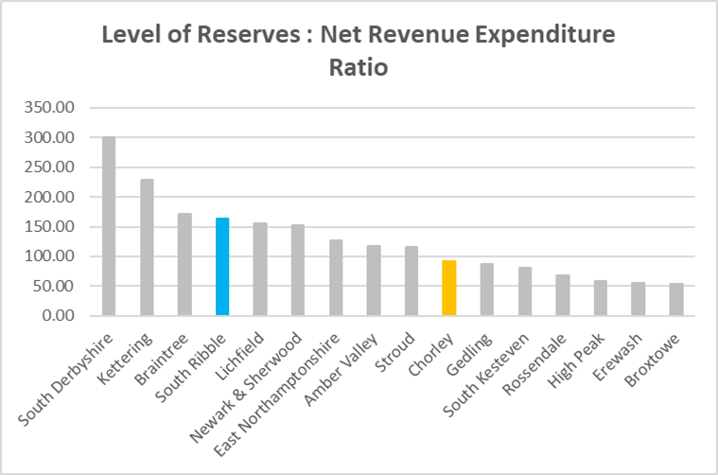

Overall rankings are broadly similar between the two years. The levels within the charts highlight reserves peaked in 2020/21 as a result of Covid Funding carried forward from 2019/20; this has subsequently been spent in line with Grant conditions.
Of the 180 districts, against this indicator South Ribble holds reserves (Earmarked and Unallocated excluding Covid grants and S31 Business Rate grants) equivalent to 125.33% of it’s annual Net Revenue, ranking them the 116th highest accordingly.
In comparison to the 12 Districts in Lancashire, South Ribble had the 5th highest level of reserves compared to net revenue.
- Change in Reserves

2021/22 | 2020/21 | 2019/20
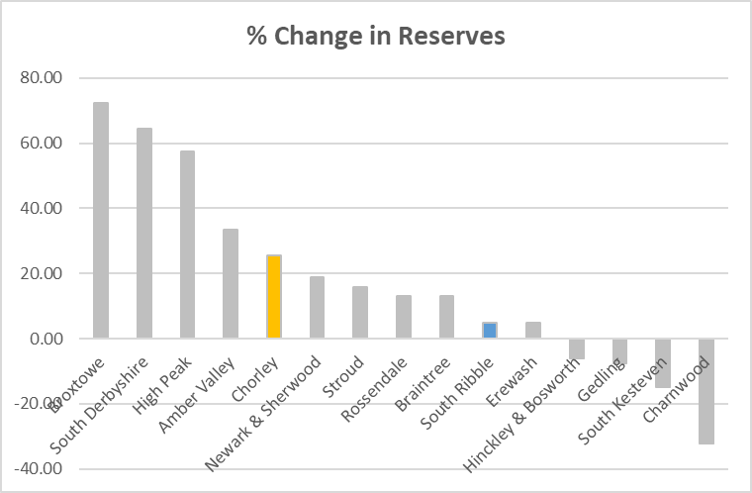 | 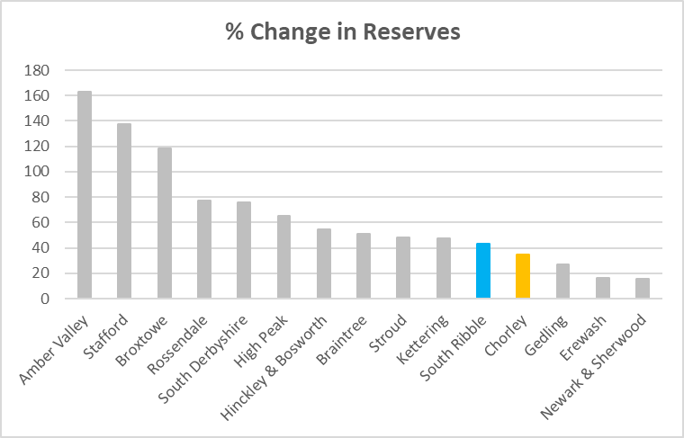 | 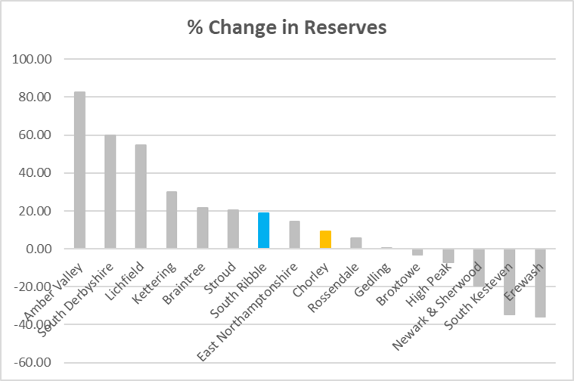

The chart highlights that the Council has consistently grown its level of reserves, however at a reduced rate in 2021/22.

In comparison, other Authorities in the group have seen their reserves decline.

The increase for 2020/21 is due to unspent Covid Funding carried forward which has now been spent in line with Grant Conditions.

- Interest Payable/Net Revenue Expenditure

2021/22 | 2020/21 | 2019/20
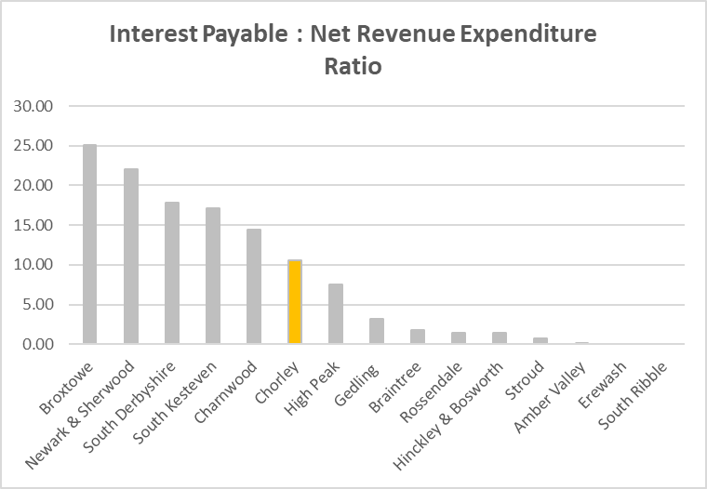 | 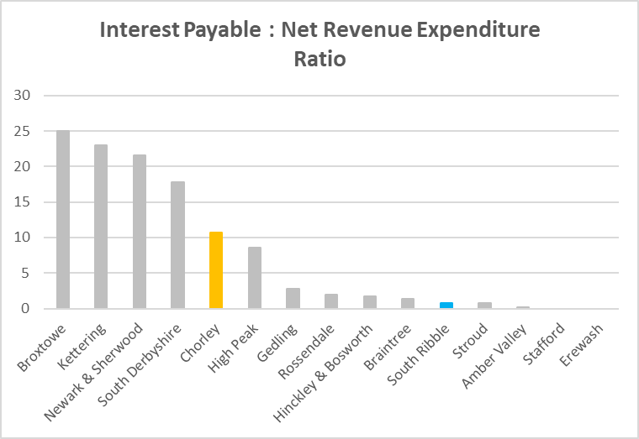 | 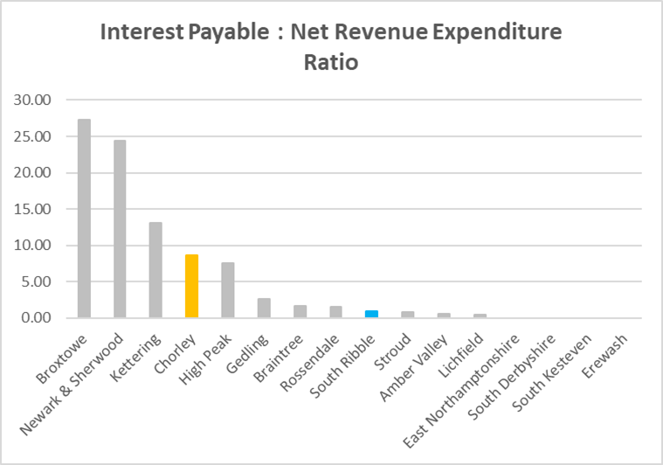

The Council is currently free from debt, hence incurring no interest payable and therefore has the lowest ranking in the group.

- Gross External Debt

2021/22 | 2020/21 | 2019/20
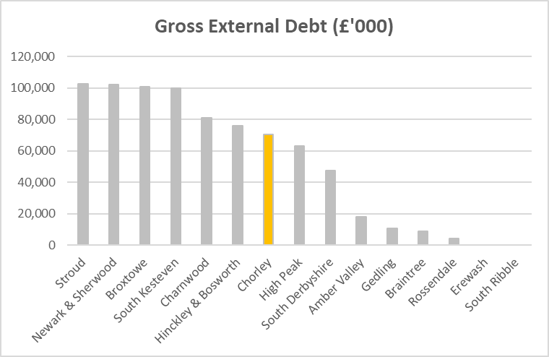 | 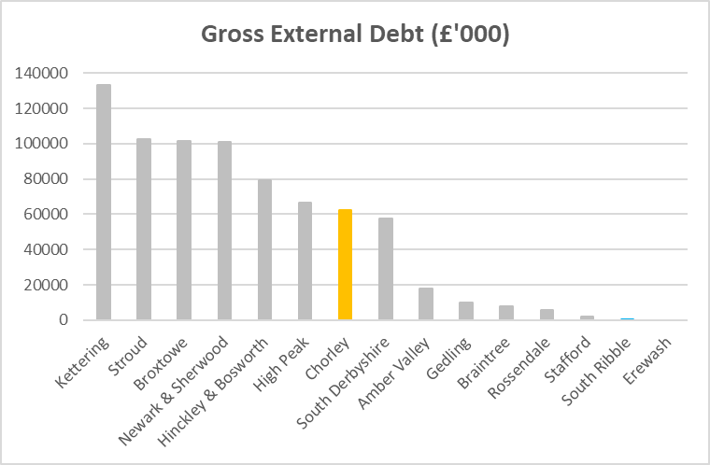 | 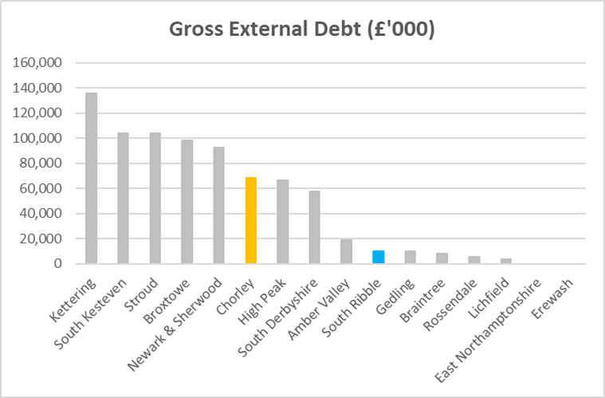

The Council’s is currently free from debt, hence the lowest ranking in the group.

This is potentially a missed opportunity to undertake improvements in the Borough and generate additional income streams, however a number of capital schemes are planned in the Borough which may require borrowing to be undertaken.

- Fees and Charges to Service Expenditure Ratio

2021/22 | 2020/21 | 2019/20
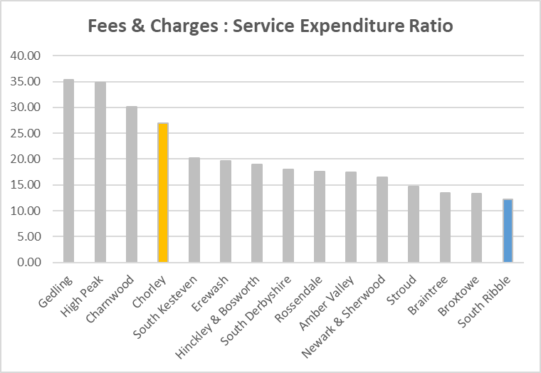 | 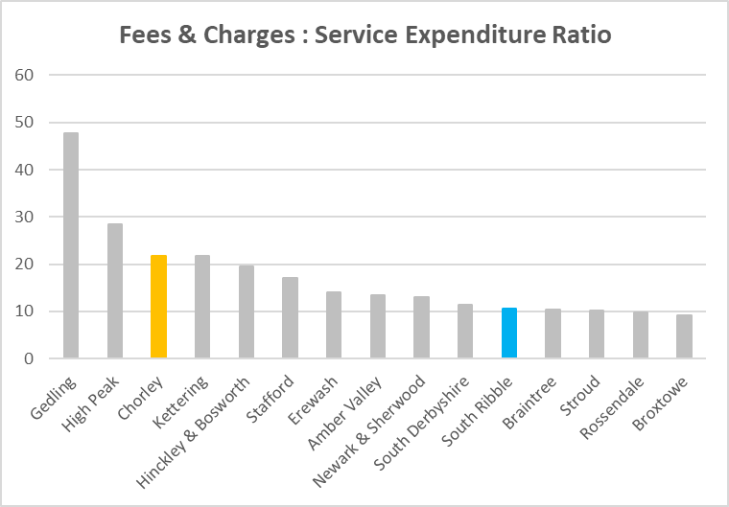 | 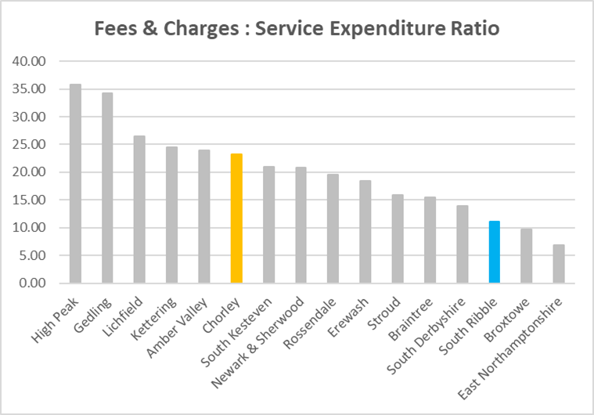

The Council is currently at the bottom of the group, suggesting the level and range of charges is low.

There is the potential for income generation to increase once planned capital schemes are completed.

- Council Tax Requirement/Net Revenue Expenditure

2021/22 | 2020/21 | 2019/20
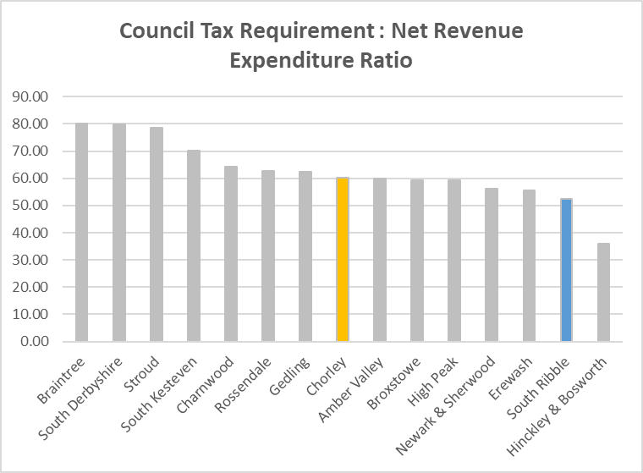 | 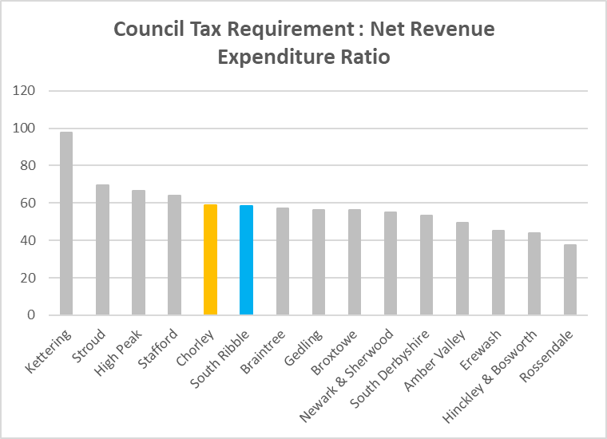 | 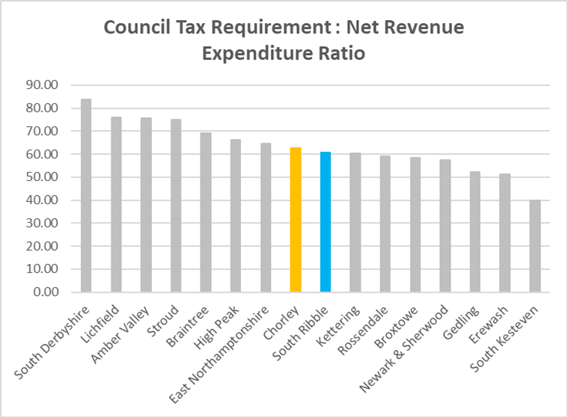

The graph above shows the level of Net Revenue Expenditure funded by Council Tax; the lower the percentage, the higher the dependency on government funding.
The Council is at the lower end of the chart given Council Tax freezes in recent years.

- Growth Above Baseline

2021/22 | 2020/21 | 2019/20
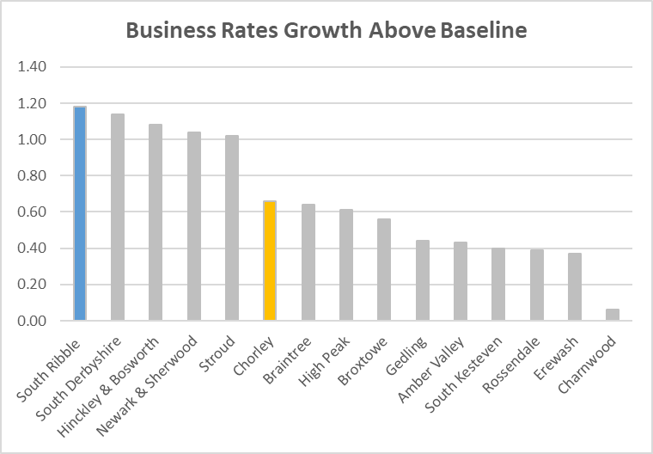 | 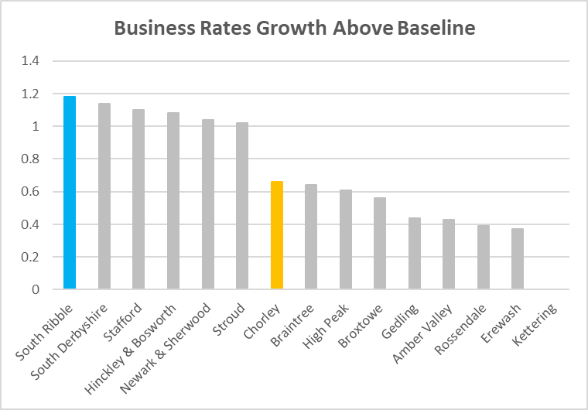 | 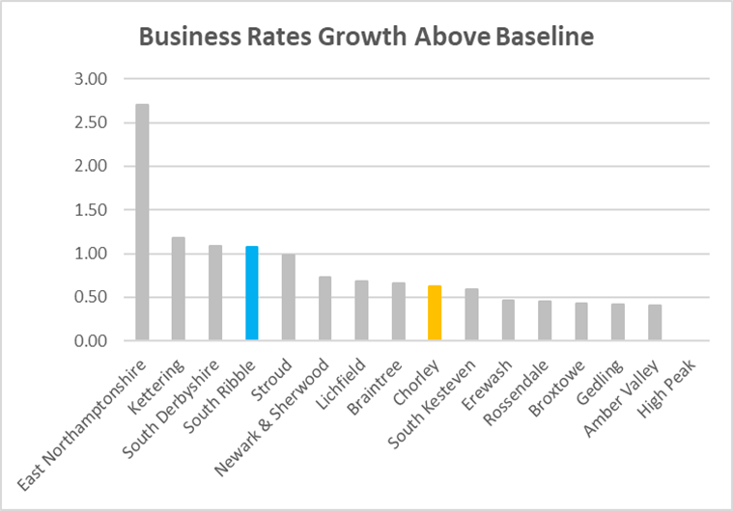

Once again the Council has achieved the highest level of Business Rates Growth.

Rather than being due to a single large development, this appears to be due to a range of smaller sites, including retail and a number of warehouse premises.

